# 

# REFERRALS/REFERIMIENTOS:

**Offices to Obtain PE Medi-Cal**

**(Escondido):**

***Centro Medico/Borrego Health- Escondido***

**1121 E Washington Ave**

**(760) 871-0606 Ext. 4742**

**Prenatal Care, PE and Medi-Cal   
(Se habla Español)**

***Neighborhood Healthcare Prenatal***

**Prenatal Care, PE and Medi-Cal**

**488 E Valley Parkway, Suite 404**

**(760) 690-5900 (Se habla Español)**

***North County Health Services***

**150 Valpreda Rd.  
San Marcos, CA 760-736-6767**

**Women’s Health**

**Insurance Options:**

**\*\*CALL FIRST**-Perinatal Care Network,**

**County of San Diego: Help with Medi-Cal**

**Paperwork AND a Medi-Cal Appointment   
 (*sooner that going to Medi-Cal office*)**

**(800) 675-2229**

**Social Services: Medi-Cal, CalWorks**

**620 E. Valley Pkwy.**

**(866) 262-9881**

**MCAP California Pregnancy Insurance  
(858)492-4422 Insurance/Aseguranza**[http://mcap.dhcs.ca.gov/Costs/Income_Guidelines.aspx](http://mcap.dhcs.ca.gov/Costs/Income_Guidelines.aspx%20)

**For a list of MD referrals and the insurance plans they accept, visit our website:**[www.amc-ca.com/](http://www.amc-ca.com/) **Your Pregnancy /Patient Education/Pregnancy Education/MD referral**

**STEPS TO CARE- REFERRALS/REFERIMIENTOS:**

**After being seen at Alternatives:**

**Step 1:**

**Obtain Presumptive Eligibility (PE)/Temporary Medi-Cal**. Choose a location from ***Offices to Obtain PE*** next column, call for an appointment. Take Verification of Pregnancy, photo ID, proof of income to that appointment. Be sure the OB provider you choose accepts the coverage you are requesting. Not all local providers accept all plans. Most in No. County SD accept Community Health Group (CHG) (see North County OB/MD Referral List).

**Step 2:**

**Call** **Perinatal Care Network (PCN) County of San Diego (800)675-2229**: To obtain pre-screening for Medi-Cal appointment and receive Medi-Cal paperwork.

**Step 3:**

**Call WIC/SDSU (888) 999-6897**: Call for appointment for food vouchers and education

**Step 4:**   
**Make an OB/MD appointment-**choose from No. County OB/MD Referral List**.  
Step 5:**  **Please keep your follow-up appointments** **here if one is scheduled and call back if we contact you. (blocked number).** A certified letter may need to be sent to your address of record if we are unable to contact you with important medical results.

**Después De Ser Vista En Alternatives*:***

**Paso 1**   
**Obtener Medi-Cal (PE) Temporal**: Elija un lugar de Oficinas para obtener PE opuesto esta página y llamar para hacer una cita. Tome Verificación del Embarazo, identificación con foto, prueba de ingreso a esa cita. Asegúrese de que el obstetra que elija para el cuidado acepta la cobertura que está solicitando. No todos los proveedores locales aceptan todos los planes. La mayoría aceptar Community Health Group (CHG) (ver lista de referencia del Condado Norte OB / MD).

**Paso 2**

**Llame PCN (800)675-2229** Para cita con Medi-Caly recibir papeleo para Medi-Cal**.**

**Paso 3 Llame WIC(888) 999-6897** Para hacer cita para cupones de comida y educacion.

**Paso 4**

**Hace cita con Provedor De Salud.-**elegir de la lista de Referencias OB/MD Condado del Norte.  
**Paso 5**   
P**or favor, mantegna su citas de seguimiento aqui y volver a llamar en caso de contacto por nosotros(numero bloqueado).** Una carta certificada puede ser enviado a su direccion de registro, si no podemos comunicarnos con usted.

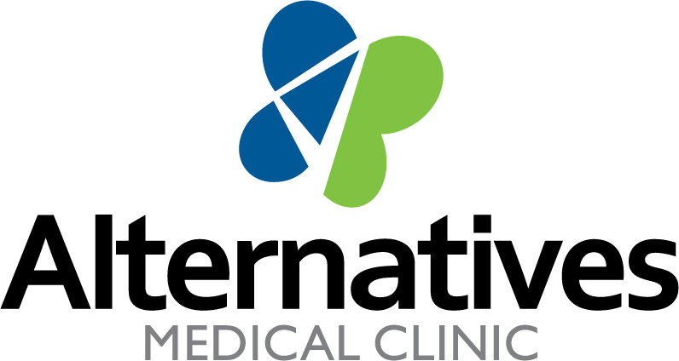

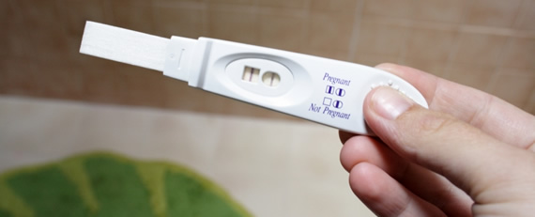

**POSITIVE PREGNANCY TEST**

257 East 2nd Avenue

Escondido, California 92025

Phone: 760-741-9796

[www.amc-ca.com](http://www.amc-ca.com)

Se Habla Español

**STEPS TO CARE**