REFERRALS/REFERIMIENTOS:

Offices to Obtain PE Medi-Cal
(Escondido):

Centro Medico/Borrego Health- Escondido
1121 E Washington Ave
(760) 871-0606 Ext. 4742
Prenatal Care, PE and Medi-Cal
(Se habla Español)

Neighborhood Healthcare Prenatal
Prenatal Care, PE and Medi-Cal
488 E Valley Parkway, Suite 404
(760) 690-5900 (Se habla Español)

North County Health Services
150 Valpreda Rd.
San Marcos, CA 760-736-6767
Women’s Health

Insurance Options:
**CALL FIRST**-Perinatal Care Network,
County of San Diego: Help with Medi-Cal
Paperwork AND a Medi-Cal Appointment
(sooner that going to Medi-Cal office)
(800) 675-2229

Social Services: Medi-Cal, CalWorks
620 E. Valley Pkwy.
(866) 262-9881
MCAP California Pregnancy Insurance
(858)492-4422 Insurance/Aseguranza
http://mcap.dhcs.ca.gov/Costs/Income_Guidelines.aspx

For a list of MD referrals and the insurance plans they accept, visit our website:
www.amc-ca.com/ Your Pregnancy /Patient Education/Pregnancy Education/MD referral

STEPS TO CARE- REFERRALS/REFERIMIENTOS:
After being seen at Alternatives:

Step 1:
Obtain Presumptive Eligibility (PE)/Temporary Medi-Cal. Choose a location from Offices to Obtain PE next column, call for an appointment. Take Verification of Pregnancy, photo ID, proof of income to that appointment. Be sure the OB provider you choose accepts the coverage you are requesting. Not all local providers accept all plans. Most in No. County SD accept Community Health Group (CHG) (see North County OB/MD Referral List).
Step 2:
Call Perinatal Care Network (PCN) County of San Diego (800)675-2229: To obtain pre-screening for Medi-Cal appointment and receive Medi-Cal paperwork.
Step 3:
Call WIC/SDSU (888) 999-6897: Call for appointment for food vouchers and education
Step 4:
Make an OB/MD appointment-choose from No. County OB/MD Referral List.
Step 5:
Please keep your follow-up appointments here if one is scheduled and call back if we contact you. (blocked number). A certified letter may need to be sent to your address of record if we are unable to contact you with important medical results.
Después De Ser Vista En Alternatives:
Paso 1
Obtener Medi-Cal (PE) Temporal: Elija un lugar de Oficinas para obtener PE opuesto esta página y llamar para hacer una cita. Tome Verificación del Embarazo, identificación con foto, prueba de ingreso a esa cita. Asegúrese de que el obstetra que elija para el cuidado acepta la cobertura que está solicitando. No todos los proveedores locales aceptan todos los planes. La mayoría aceptar Community Health Group (CHG) (ver lista de referencia del Condado Norte OB / MD).
Paso 2
Llame PCN (800)675-2229 Para cita con Medi-Cal y recibir papeleo para Medi-Cal.
Paso 3 Llame WIC(888) 999-6897 Para hacer cita para cupones de comida y educacion.
Paso 4
Hace cita con Provedor De Salud.-elegir de la lista de Referencias OB/MD Condado del Norte.
Paso 5
Por favor, mantegna su citas de seguimiento aqui y volver a llamar en caso de contacto por nosotros(numero bloqueado). Una carta certificada puede ser enviado a su direccion de registro, si no podemos comunicarnos con usted.

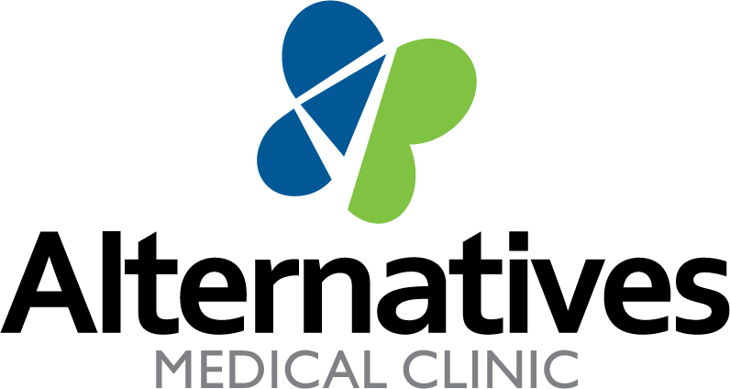

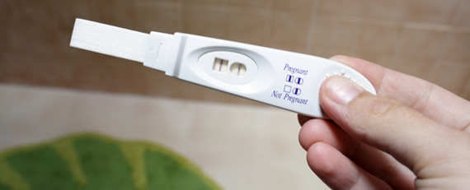

POSITIVE PREGNANCY TEST
257 East 2nd Avenue
Escondido, California 92025
Phone: 760-741-9796
www.amc-ca.com
Se Habla Español

STEPS TO CARE

